**Kitchen Story Application - Phase 4**

## **Github Url** - <https://github.com/SathishSubramanian96/KitchenStory_application.git>

## **Table of contents**

* General info
* Using the application
* Technologies
* Setup

## **General info**

A simple online based application using technologies such as HTML, CSS . The application consists of three modules namely quiz, results and review.

## **Using the application**

* User can start the app by opening the index.html through chrome browser.

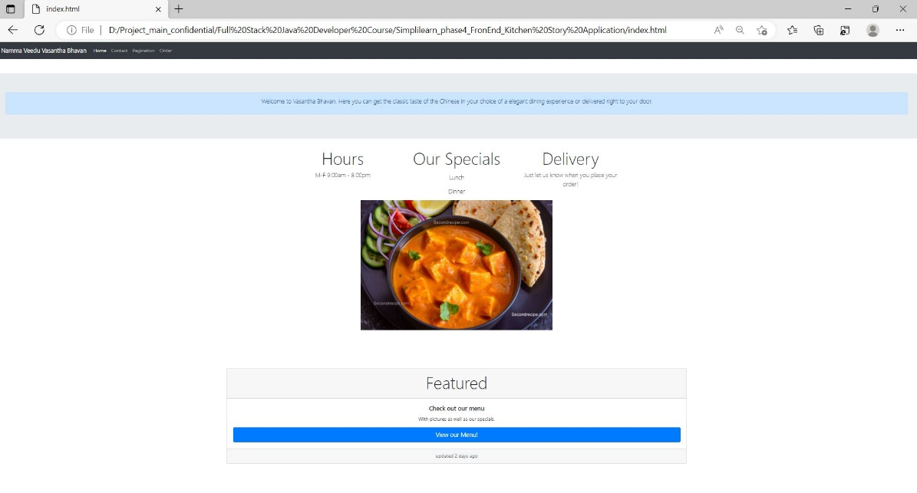

* User can view the menu of restaurant using **view our menu** button.



* User can provide rating, feedback and mail id for contact purpose under the **Contact** section as shown below.

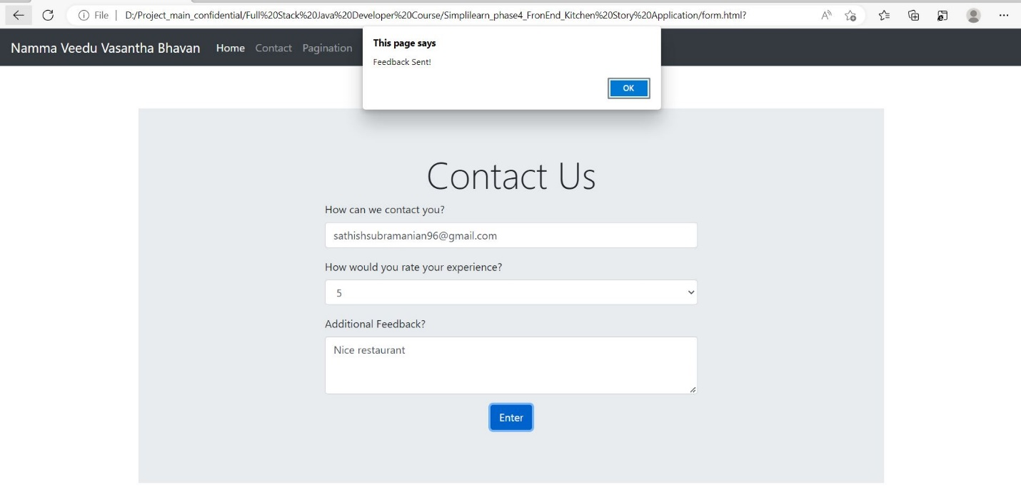

* User can provide the orders through the order menu by selecting the food option from the dropdown as shown in the diagram.

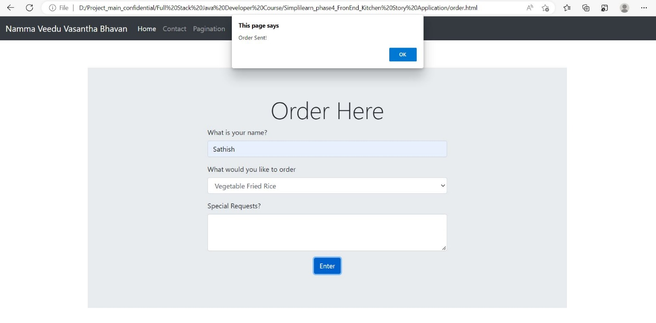

## **Technologies**

Project is created with:

* HTML (Hyper Text Markup Language).
* CSS (Cascade Styling Sheets).
* Bootstrap, Jquery.
* Internet Browser(Chrome).

## **Setup**

Open the index.html document via Browsers (Chrome, Microsoft Edge, etc.,).